**INTERNET PROGRAMMIN**

**[** 21CS209 **]**

**ASSIGNMENT – I**

|  |  |
| --- | --- |
| Content [14] |  |
| References [2] |  |
| Presentation [2] |  |
| Timely Submission [2] |  |
| Total [20] |  |

**Submitted by : Submitted to :**

C Hariharan Mrs.J.Shanthalakshmi Revathy

21CSE106 Professor

Department of Computer Science Velammal College of Engineering And Technology

Madurai

**Question :**

Create your own interactive webpage using different types of stylesheets (use inline, internal and external CSS). The webpage should display

1. Name the website like I am a web developer
2. Website name have to be displayed at the top center of the webpage on an image. Apply some text effects to the website name.
3. Create four tab like home, about me, skills and contact. Give internal reference to all these contents
4. Display some welcome content in home page. Set suitable font, text and color properties for the content
5. In about me display ur image with some contents.
6. Display my skills in table format. Apply border properties for the table.
7. In the left side of the webpage at a particular part use animation and transformations to display the text. The images of the courses have to change at a particular interval

**The Solutions :**

**Program :**

<!--Main Page-->

<!DOCTYPE html>

<html lang="en">

<head>

<meta charset="UTF-8">

<link rel="stylesheet" href="forassi.css">

<meta http-equiv="X-UA-Compatible" content="IE=edge">

<meta name="viewport" content="width=device-width, initial-scale=1.0">

<title>Me the Developer</title>

</head>

<body style="background-color: rgb(219, 219, 219); font-family: Bahnschrift;">

<div>

<img id="ban" src="D:\DOWNLOADS\stds\Sem 4\IP\Assignment\1\name.png">

</div>

<div id="tabs">

<h2> &emsp;&emsp;&emsp;&emsp;&emsp; <a href="#home" style="text-decoration: none; color: white;">&emsp;&emsp; Home &emsp;&emsp;</a> &emsp;&emsp;&emsp;&emsp;&emsp; <a href="#me" style="text-decoration: none; color: white;">&emsp;&emsp; About &emsp;&emsp;</a> &emsp;&emsp;&emsp;&emsp;&emsp;

<a href="#dex" style="text-decoration: none; color: white;">&emsp;&emsp; Dexterity &emsp;&emsp;</a> &emsp;&emsp;&emsp;&emsp;&emsp;<a href="#cnt" style="text-decoration: none; color: white;">&emsp;&emsp; Message me &emsp;&emsp;</a> &emsp;&emsp;&emsp;&emsp;&emsp;&emsp; </h2>

</div>

<div id="main">

<br><br>

<h1 id="home"> &emsp;&emsp;&emsp;&emsp; Hey hi this is me C Hariharan,</h1>

<h3> &emsp;&emsp;I've done my Schooling's in "Jain Vidhyalay Mat. Hr. Sec. School", where I choose Computer Science as main Course after the 12th Grade. I have pursued there for about Six( 6 ) Years that is from the 7th grade to the 12th Grade.

Lorem ipsum dolor sit amet consectetur adipisicing elit. Modi cupiditate illum hic! Maxime tenetur commodi perferendis quasi similique autem, reprehenderit nihil nemo aliquid sunt enim. Magnam unde doloribus ipsam iusto.

Lorem ipsum dolor, sit amet consectetur adipisicing elit. Eveniet velit, pariatur id suscipit aspernatur soluta excepturi! Repellat non perferendis eos aut eius magni. Laboriosam, minima nostrum. Autem fugiat aliquid cum.

Lorem ipsum dolor sit, amet consectetur adipisicing elit. Libero cum nesciunt atque blanditiis corporis possimus, eum architecto expedita quia sunt consectetur doloribus quas voluptate provident officiis odio veniam illum saepe.

Lorem ipsum dolor sit amet consectetur adipisicing elit. Earum, distinctio voluptates, libero repudiandae omnis debitis quidem laboriosam facilis eum voluptas optio assumenda error blanditiis neque provident laudantium ullam explicabo doloremque?

Lorem ipsum dolor sit amet consectetur adipisicing elit. Officiis, necessitatibus sed. Quia omnis in, deserunt blanditiis illo distinctio! Voluptate voluptatibus at excepturi officia, assumenda ipsa repudiandae commodi! Similique, molestiae natus!

Lorem ipsum dolor sit amet consectetur adipisicing elit. Vel officiis, soluta maxime sapiente natus earum possimus! Iste doloribus provident magni reiciendis autem ducimus enim cum, quos velit obcaecati, id eligendi.

<br> And i've done even many more things in my life.

</h3>

<hr>

<img id="pp" src="https://previews.123rf.com/images/dafnadar/dafnadar1707/dafnadar170700015/82894770-handsome-young-adult-men-in-shirt-and-trousers-hand-drawing-illustration-with-black-line-art-man-wit.jpg">

<h1 id="me">To speak about me,</h1>

<h3>&emsp;&emsp; In fact there is nothing much to speak about me. But let's just talk about me for now.<br>

<br>Lorem ipsum dolor sit amet consectetur adipisicing elit. Maiores vero eaque inventore iste perferendis ut nemo doloribus quisquam porro saepe quia, rerum fugit mollitia tempora, cum quam quis eos. Accusamus!

Lorem, ipsum dolor sit amet consectetur adipisicing elit. Consequatur a deleniti, quibusdam placeat pariatur quidem incidunt! Tenetur, quos ut officia, amet suscipit vel repudiandae dignissimos facere veritatis possimus, nisi consequuntur.

Lorem ipsum dolor, sit amet consectetur adipisicing elit. Commodi libero modi alias tenetur est consectetur, quam error quibusdam id architecto doloremque sequi similique dolorum eaque dolores, tempora laborum voluptatibus magni.

Lorem ipsum dolor, sit amet consectetur adipisicing elit. Incidunt, aperiam repellendus voluptatibus ducimus corporis nam mollitia quisquam dolores sapiente neque ullam eius tempore ut, temporibus quae, quia obcaecati dignissimos culpa.

<br><br> If this is just not enough about me,

Lorem ipsum, dolor sit amet consectetur adipisicing elit. Voluptates, voluptatibus! Fuga illo doloremque sint, iusto nihil esse beatae excepturi cupiditate nam eos accusamus eius nemo culpa nobis provident minima dolor.

Lorem ipsum dolor sit amet consectetur adipisicing elit. Magnam debitis praesentium vero eos. Quaerat consequatur totam aut, id nostrum dignissimos, similique quidem perspiciatis quisquam dolorem dolore harum laudantium nobis iusto.

Lorem ipsum dolor sit amet consectetur adipisicing elit. Aperiam, accusamus? Perferendis quis assumenda, ad cupiditate, soluta vitae dolor dolorem quidem itaque, commodi atque maiores eos reiciendis suscipit ipsam quia distinctio.

<br><br> Yeah! that's all me.</h3>

<hr>

<h1 id="dex">My Dexterities are as follows,</h1>

<h3 class="bld">Tenth Grade - Made it in Jain Vidhyalay School, Madurai with a Score of ___ %</h3>

<h3 class="bld">Eleventh Grade - Made it in Jain Vidhyalay School, Madurai with a Score of ___ %</h3>

<h3 class="bld">Twelth Grade - Made it in Jain Vidhyalay School, Madurai with a Score of ___ %</h3>

<h3 class="bld">Artworks - Lorem ipsum dolor sit amet consectetur adipisicing elit. Asperiores quas id dolor accusamus accusantium omnis sapiente qui inventore alias illo labore delectus, excepturi deserunt consequatur tenetur iusto, cupiditate quisquam nulla?</h3>

<hr>

<h1 id="cnt">Just contact me without worries,</h1>

<h3>Name </h3><input type="text">

<h3>Age </h3><input type="number">

<h3>E-Mail </h3><input type="email">

<h3>Compose the Message</h3><input type="text">

<div id="btn"><a href="" style="text-decoration: none;color: white;"><h2>&emsp;&emsp; Just Submit the Message &emsp;&emsp;</h2></a></div>

</div>

<div id="end">

<h3>Copyright &#169; from 2023 of Febraury - Me the Developer</h3>

</div>

</body>

</html>

<!—The Css page>

#ban

{

width: 100%;

height: 600px;

}

#tabs

{

width: 100%;

margin-top: -5%;

position:absolute;

padding: 1%;

text-align: center;

color: white;

font-family: Bahnschrift;

background-color: black;

}

#main

{

margin-left: 15%;

margin-right: 15%;

background-color: white;

margin-top: -1%;

padding-left: 5%;

padding-right: 5%;

padding-bottom: 5%;

}

::-webkit-scrollbar {

width: 10px;

}

::-webkit-scrollbar-thumb {

background: rgb(234, 255, 77);

border-radius: 10px;

}

::-webkit-scrollbar-thumb:hover {

background: #8d9eff;

}

#end

{

background-color: black;

padding: 2%;

color: white;

text-align: center;

}

#btn

{

color: white;

background-color: black;

padding: 1%;

margin-top: 2%;

margin-left: 5%;

margin-right: 40%;

text-align: center;

}

#pp

{

justify-items: center;

width: 30%;

}

.bld

{

font-weight: bolder;

}

**Output :**

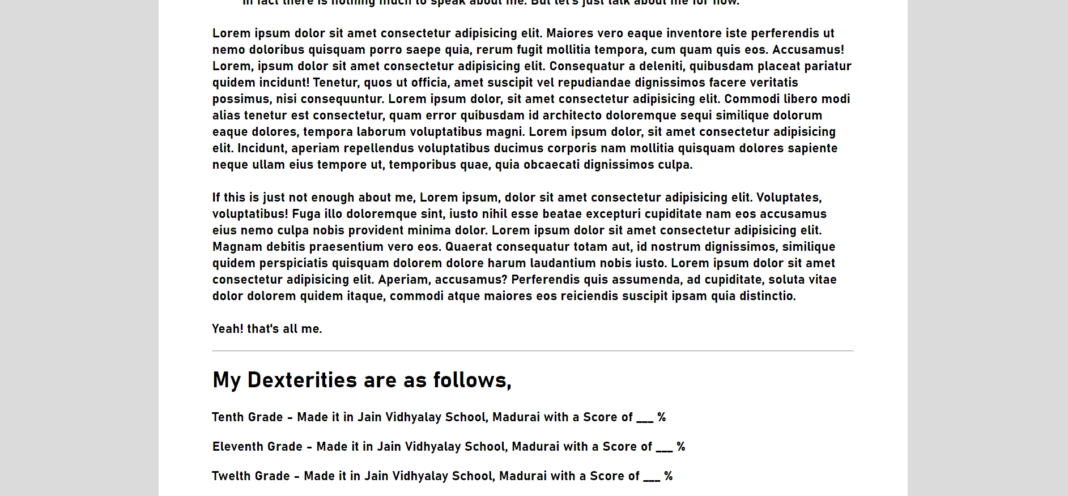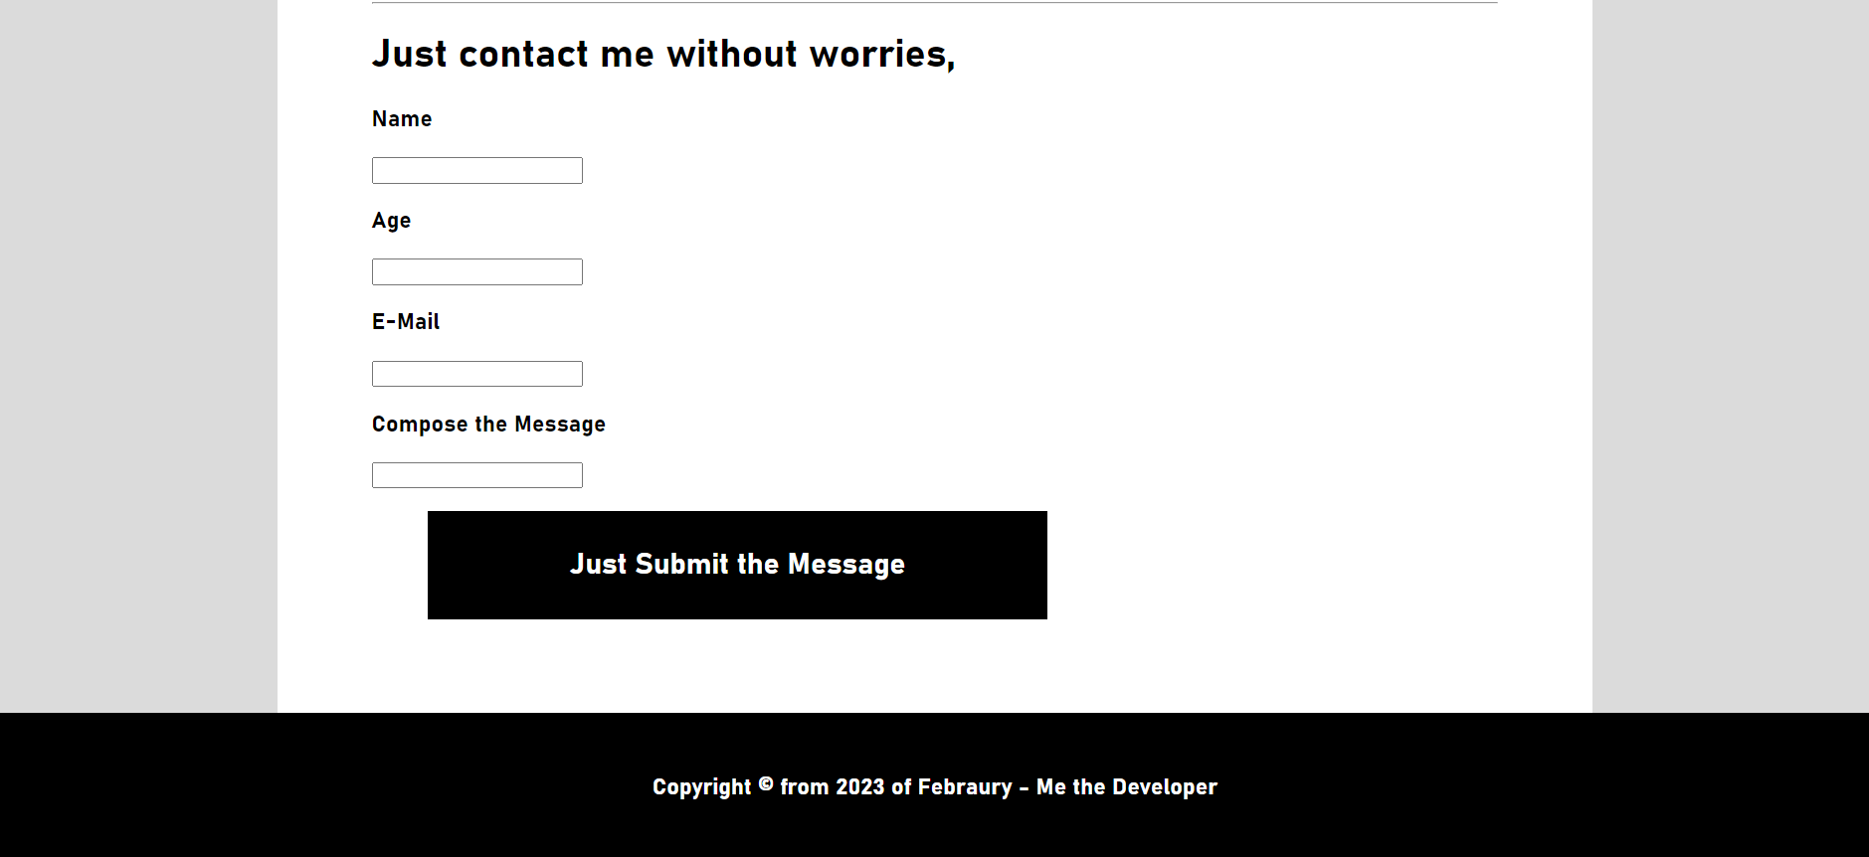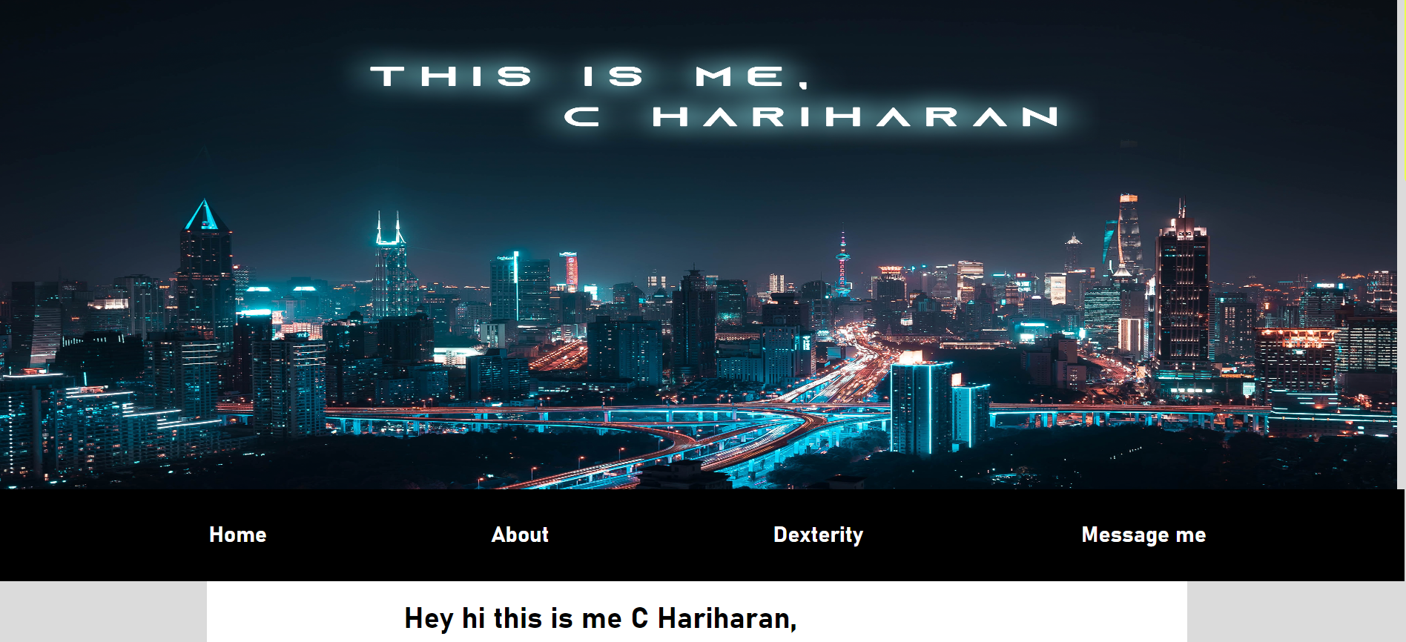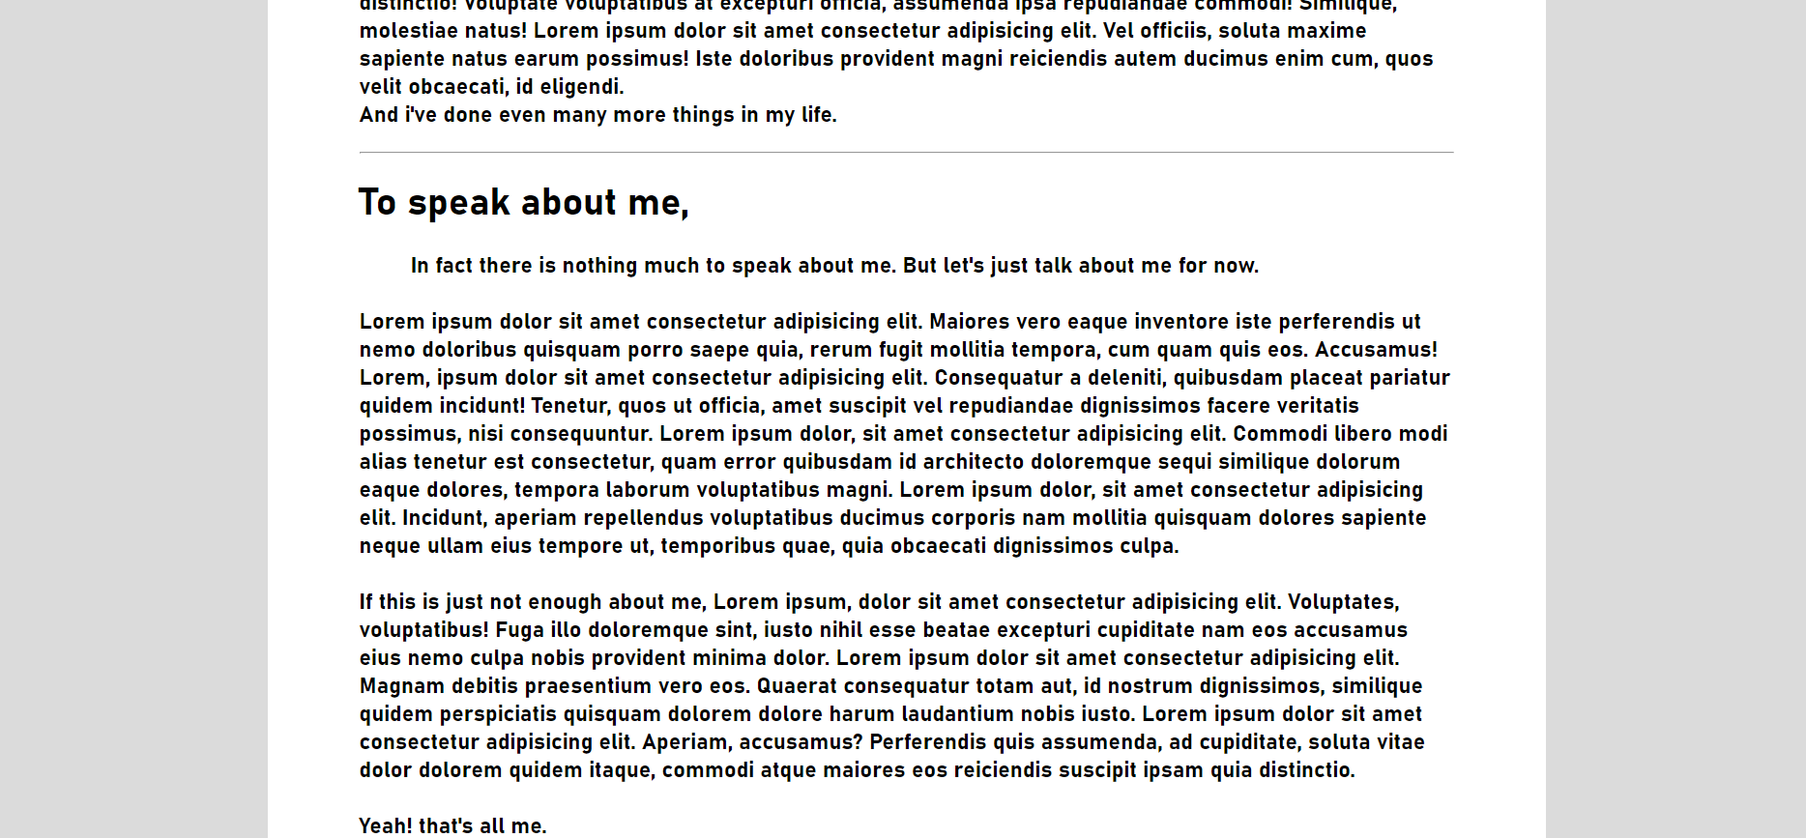

**References :**

**I -** [**https://www.w3schools.com/howto/tryit.asp?filename=tryhow_css_custom_scrollbar**](https://www.w3schools.com/howto/tryit.asp?filename=tryhow_css_custom_scrollbar)

**2 -** [**https://www.youtube.com/**](https://www.youtube.com/)

**3 -** [**https://www.rapidtables.com/web/html/html-codes/html-code-copyright.html**](https://www.rapidtables.com/web/html/html-codes/html-code-copyright.html)

**4 -** [**https://stackoverflow.com/questions/18729338/how-to-make-a-div-appear-on-top-of-everything-else-on-the-screen**](https://stackoverflow.com/questions/18729338/how-to-make-a-div-appear-on-top-of-everything-else-on-the-screen)

**5 -** [**https://books.google.co.in/books?id=nckIAAAAQBAJ&pg=PT361&lpg=PT361&dq**](https://books.google.co.in/books?id=nckIAAAAQBAJ&pg=PT361&lpg=PT361&dq)